**Task Description**

Each trial, the subject has to decide whether or not to play one of five different slot machines. Each machine generates a normally distributed monetary prize around the means -2, -1, 0, 1, 2, each with a standard deviation of 2.

The subject needs to decide if she wants to play the machine (choice = Yes, by pressing the left arrow) or not (choice = No, by pressing the right arrow ). If the subject chooses No, the reward for the trial, denoted rₜ, is 0. If the subject chooses Yes, the reward for the trial is a randomly selected value within the normal distribution for the slot machine.

Importantly, the subject does not know which of the five machines it is, in order to avoid learning effects across trials. Instead, she makes her decision based on value samples about the payouts associated with the slot machine.

In particular, an independent value sample is shown to the subjects every 200 ms with a 100ms blank screen in between until she makes a choice, for a max of 12s. These samples are drawn from the normal distribution that characterizes the payouts associated with the machine.

The value samples are represented using visually colored circles, with the color reflecting the valence of the value (green = positive, red = negative), and the size of the circle reflecting the magnitude of the value. Each randomly selected sample value will fall within a predetermined bin within the distribution of all potential values produced by all 5 machines. Each bin corresponds to a circle that will represent each value within the bin. There are 4 bins per interval (1) and 6 intervals, resulting in 24 different stimuli representing all potential values selected by the 5 machines. The division of the distribution is presented below:

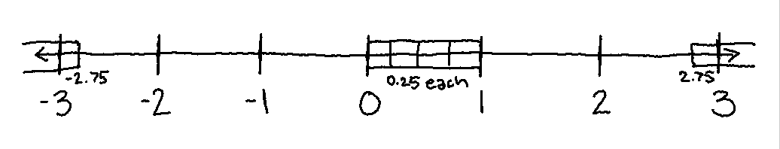

Each trial, the reward of playing the machine is a randomly selected value within the distribution of the slot machine being presented in the trial.

Here is the timing of the trial: 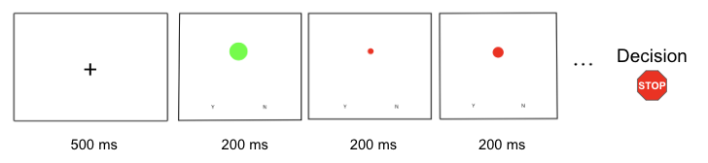

Note:

* Trials are separated by a 1s blank screen
* There will be 10 practice trials
* If the subject does not make a choice within 12s, a screen prompting them to respond faster on the next trial will appear for 1.5s
* The bins representing the largest and smallest values will be extended to include all values greater than 2.75 and all values less than -2.75, respectively, allowing for any values greater than 3 or less than -3
* The order of machines is randomly selected with the following constraint: each machine is shown 60 times in the experiment (30 in each block). Note that the same machine might be shown in two subsequent trials.

The experiment is structured as follows:

1. Subjects are given task instructions
2. Subjects participate in 6 blocks of 50 trials for 300 trials total (with a maximum duration of 12s per trial, 13.5 if they are too slow to respond)
3. Subject compensation for the task is determined and has two components:
   * A guaranteed show-up payment of $10
   * Extra payoff of the sum of earnings from 12 randomly selected trials (2 from each blocks), with a minimum of $0. For a subject that chooses optimally, the expected extra payoff is $12.